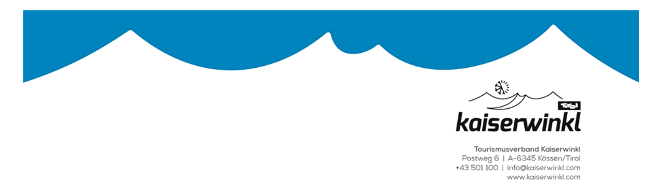**Application for the**

**Reward for Regular-Guest in the Kaiserwinkl**

|  |  |
| --- | --- |
| First name, last name | Birth date |
|  |  |
|  |  |
|  |  |
|  |  |

**Address of your home country:**

Street:…………………………………………………………………………….. Postal code/City:……………………………………………

Country: …………………………………………….……………….. Telephone: ……………………………………………………………......

E-Mail (free e-mail newsletter ok): ……………………………………………………………………………………………………..

**Accommodation in the Kaiserwinkl:** …………………………………………………………………………………………………

**Last reward was at** …………………………………………. (date) for ................... stays

**Stays from 7 days on** (please make a list of all or from the last reward):

|  |  |  |
| --- | --- | --- |
| Day / Month / Year | **Day / Month / Year** | **Day / Month / Year** |
|  | 11. | 21. |
|  | 12. | 22. |
|  | 13. | 23. |
|  | 14. | 24. |
|  | 15. | 25. |
|  | 16. | 26. |
|  | 17. | 27. |
|  | 18. | 28. |
|  | 19. | 29. |
|  | 20. | 30. |

Distinction **in 🞎** Walchsee (Tuesday) **🞎** Kössen (Thursday) at 5 p.m. at .......................... (date)

**🞎** or through your host in your accommodation

............................................. ............................................. .............................................

Guest Host / Stamp Tourism office Kaiserwinkl

Please bring or send the application for the regular guest reward at least 3 days before the reward date to the tourism office or per E-mail to [info@kaiserwinkl.com](mailto:info@kaiserwinkl.com)